

Breast Cancer Detection

Nitika Agarwal

179302095

# **Breast Cancer Prediction Flow Chart**

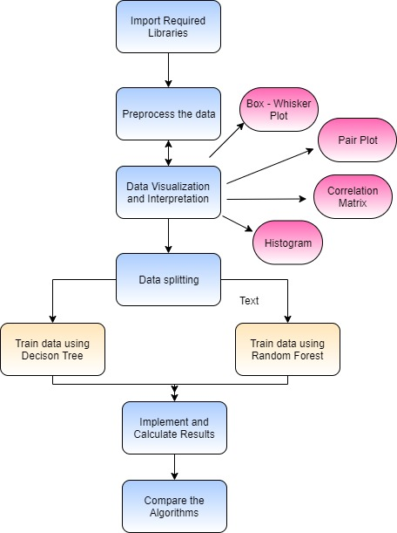

Apply

naïve Bias

Apply SVM

# **Dataset Information**

Original Dataset

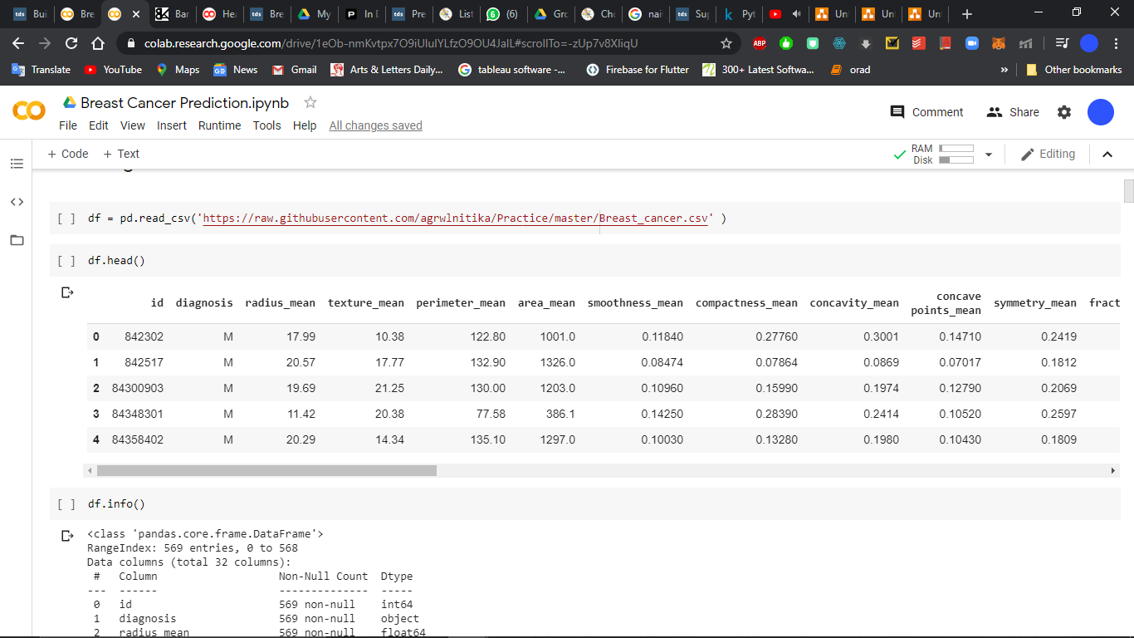

Preprocessed Dataset

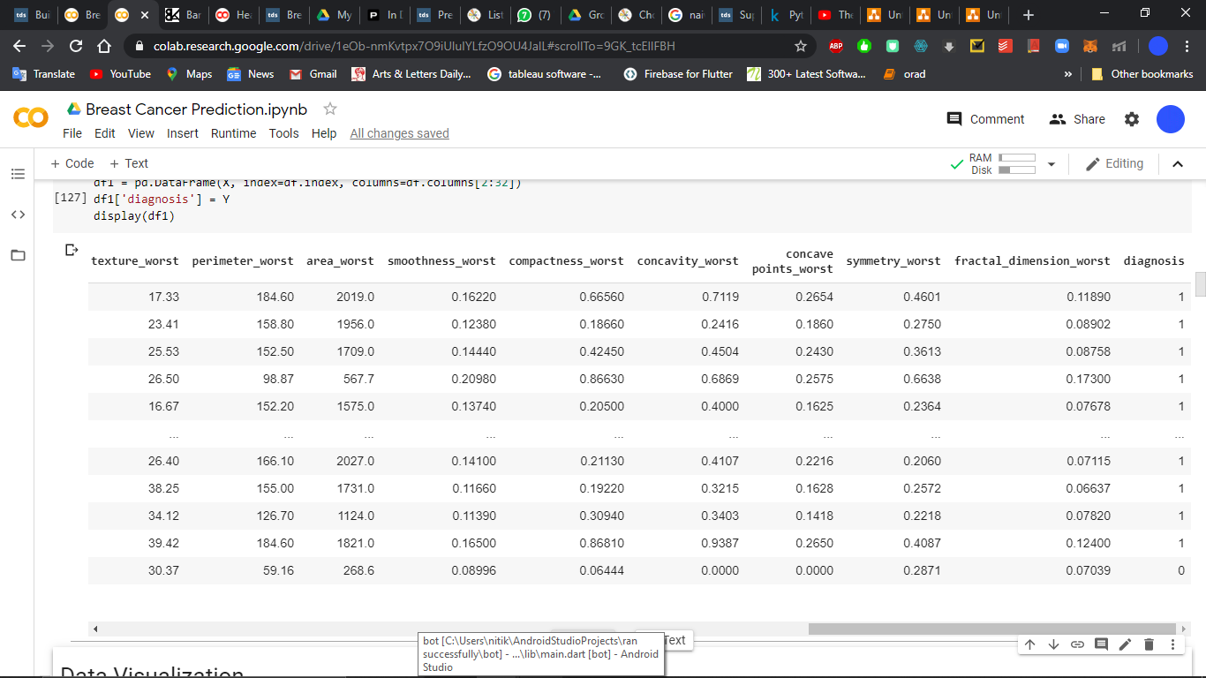

# **Dataset Interpretations**

Histograms

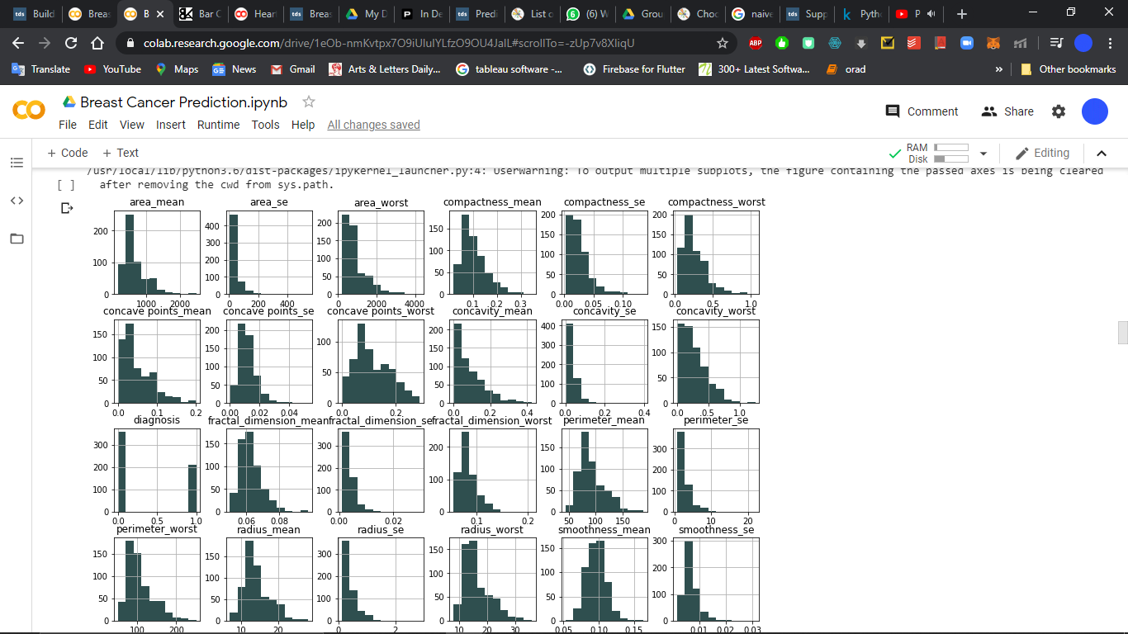

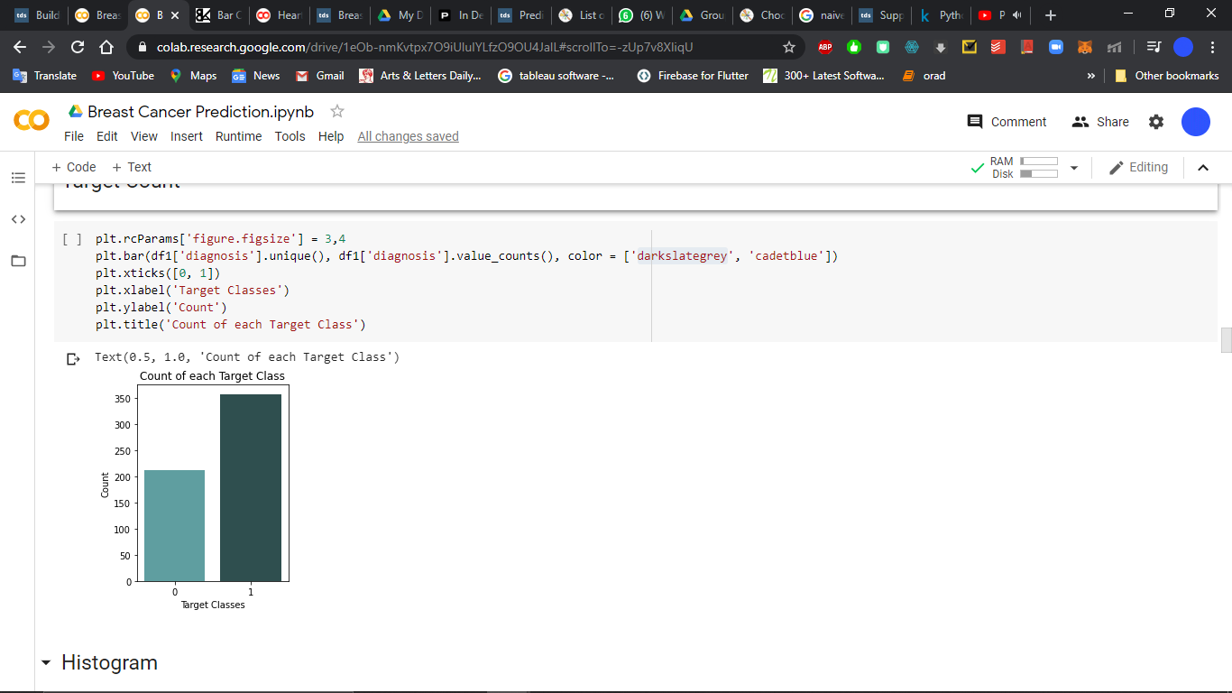Target Classes

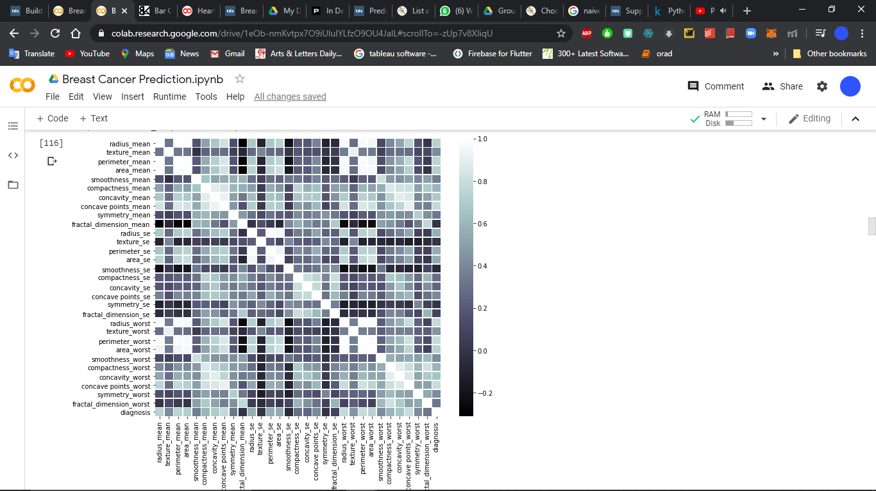Correlation Matrix

# **Support Vector Machine**

Classification report and Confusion Matrix

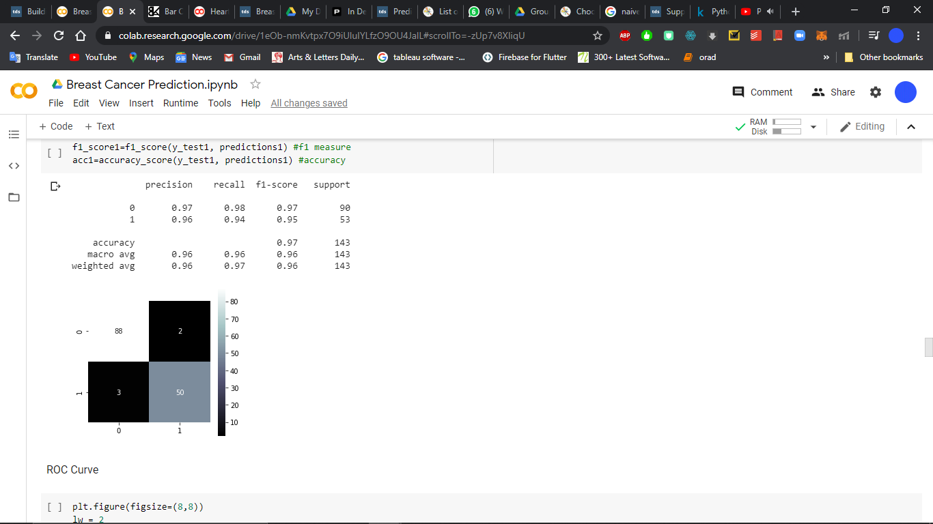

Reciever Operating Curve

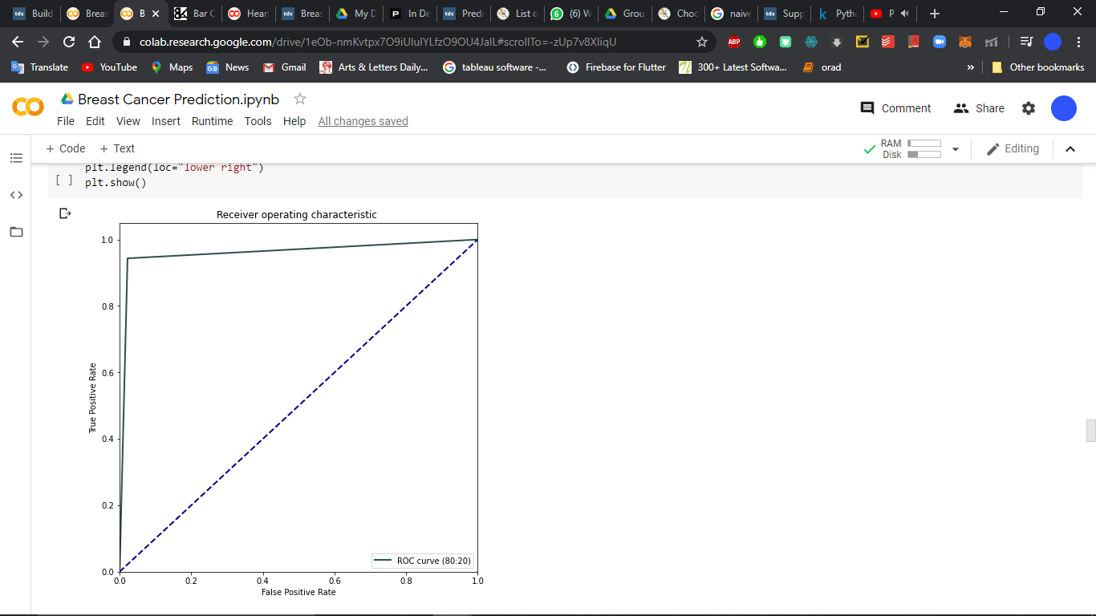

Results in Tabular Form

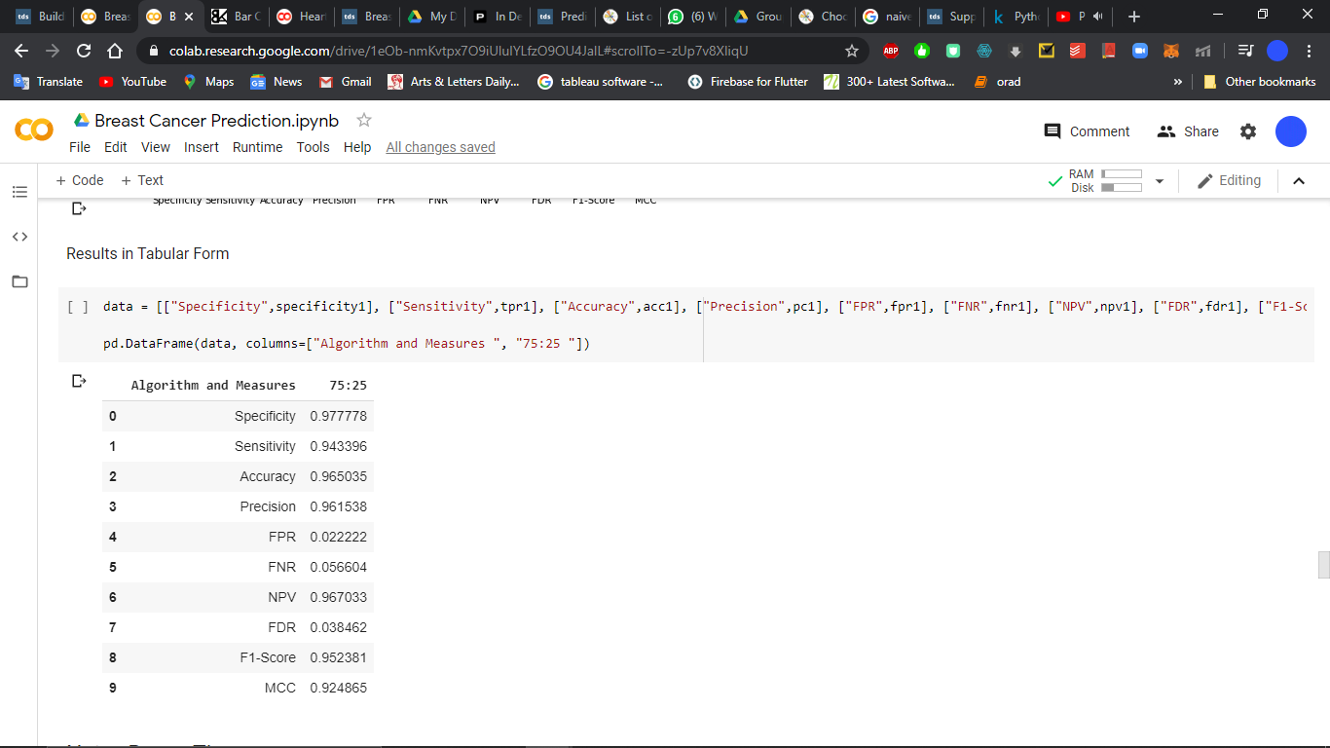

Results in Graphical Form

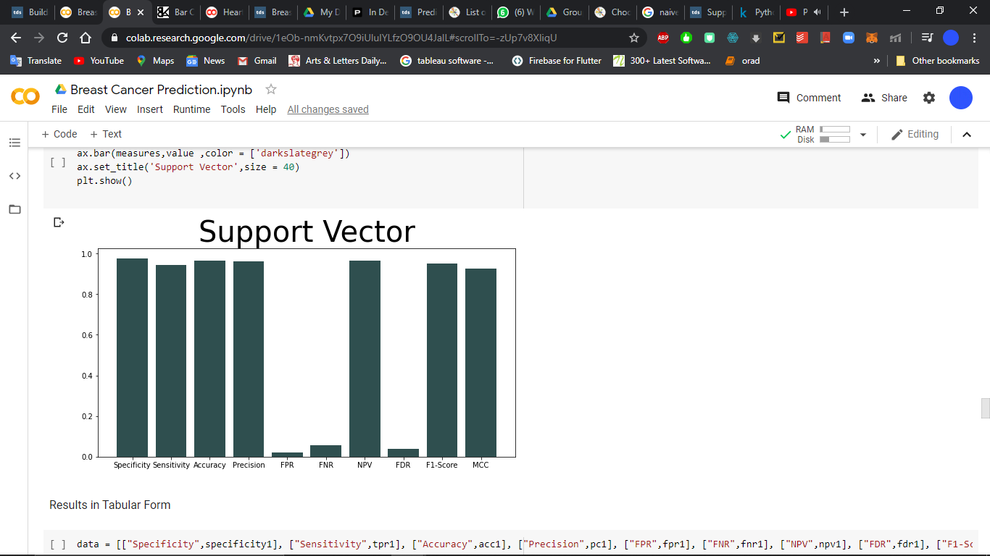

# **Naïve Bayes Algorithm**

Classification report and Confusion Matrix

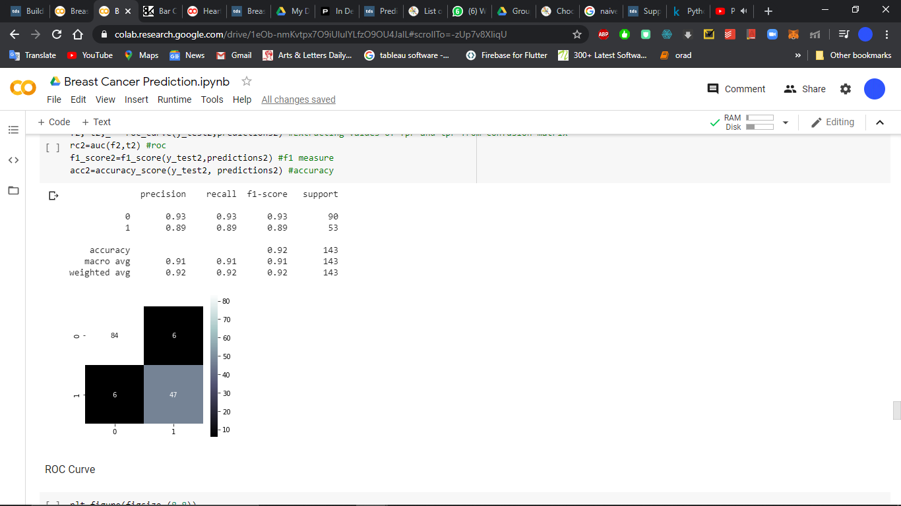

Reciever Operating Curve

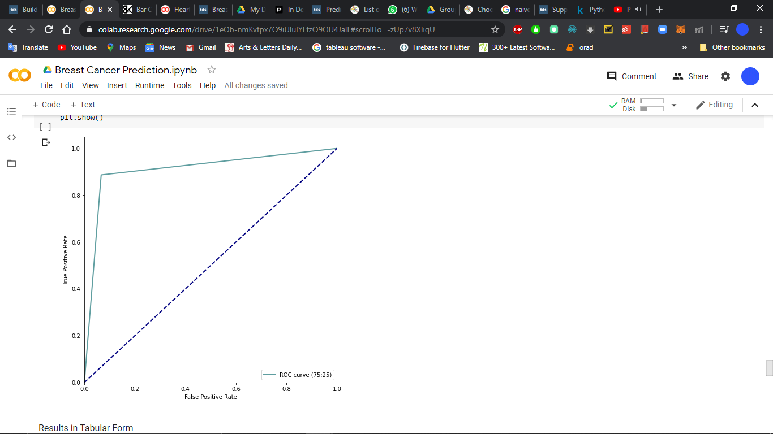

Results in Tabular Form

Results in Tabular Form

Results in Tabular Form

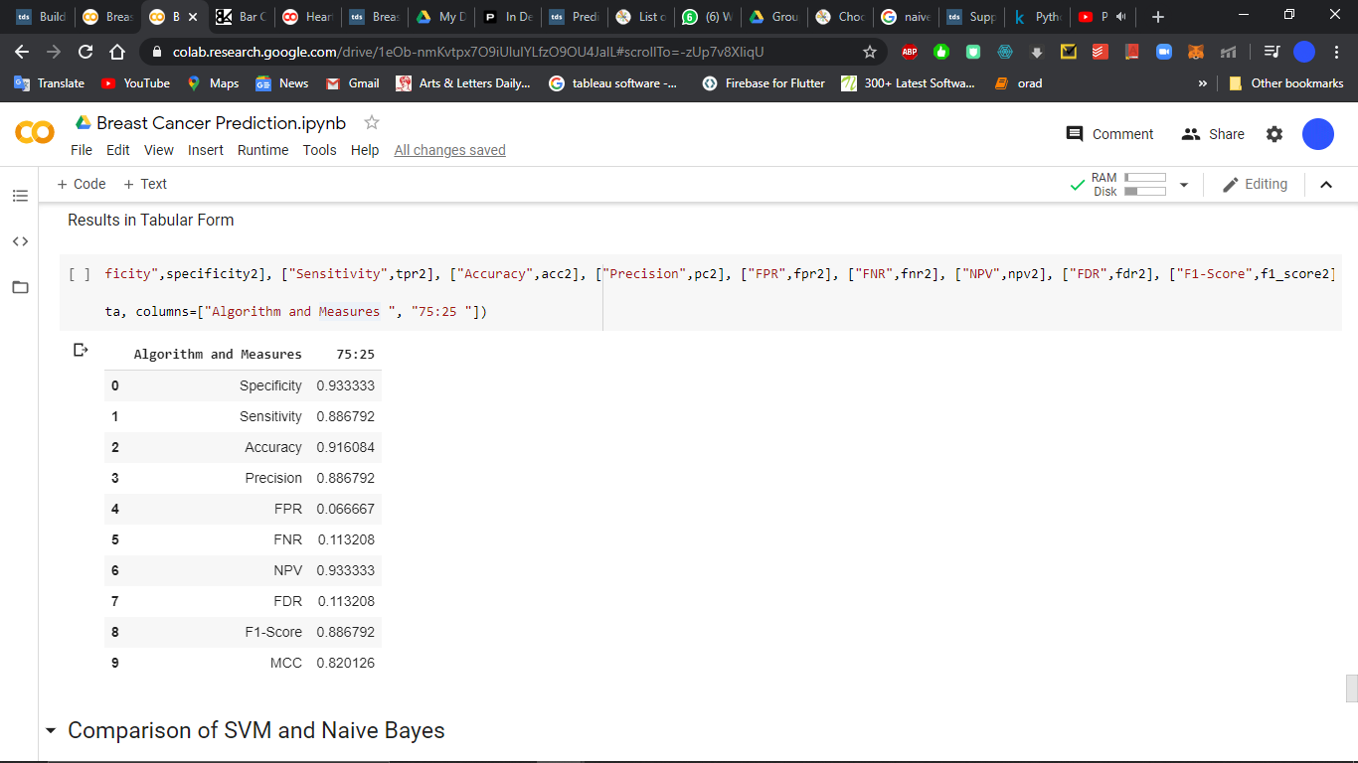

Results in Graphical Form

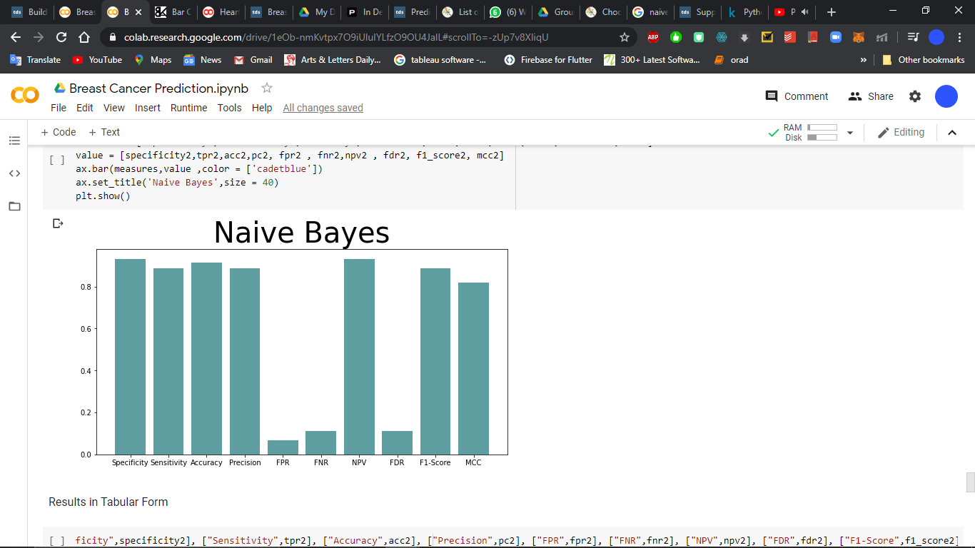

# **Naïve Bayes vs Support Vector Machine**

Results in Tabular Form

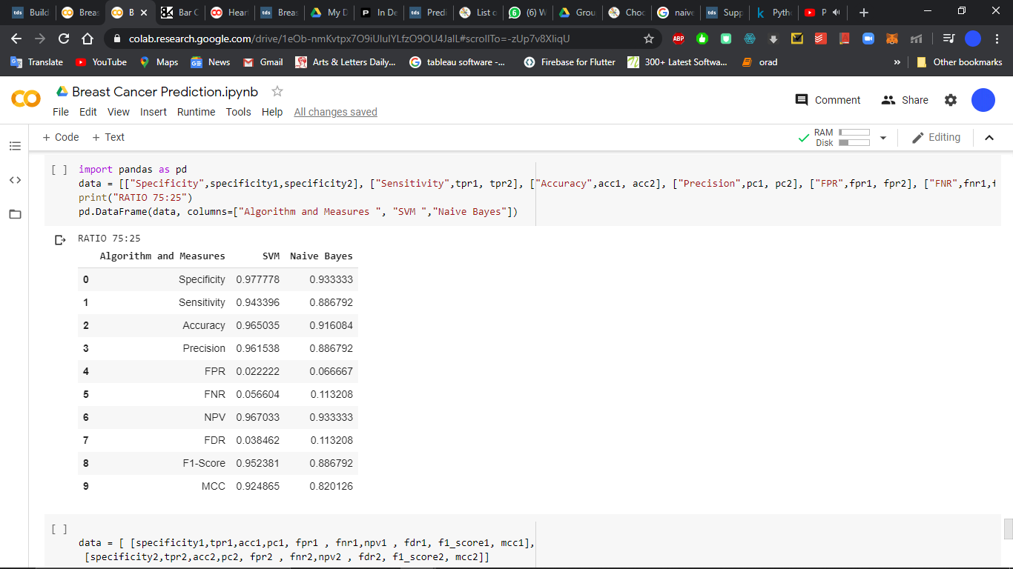

Results in Graphical Form

